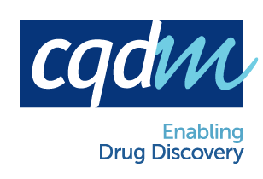

CQDM’s Canada/Europe joint funding initiative
Partnering Interest Form

Country and region (when applicable) to partner with :
For Europeans: Canada :
For Canadians: Germany : ; France : Alsace Rhône-Alpes; Belgium : Wallonia

Note: European applicants need to be from the private sector. Canadian applicants can be both from the private or public sector.

IDENTIFICATION
Name: |  |  |  |  |  |  |  | Surname:
Company / University :
Address:
Country : |  |  |  |  |  | Telephone :
Email :

Brief description of your sector of activity.
Brief description of the expertise looked for in the partner and potential role

KEYWORDS describing the proposed research project

Keywords to describe your expertise Keywords for requested partner expertise

Therapeutic Domain/Indication |  | Therapeutic Domain/Indication

Technical Expertise |  | Technical Expertise

Name of potential partner (if applicable):

October 2015

